**Project Proposal for Poetry Generating AI**

David Devore, Nathan Smith

**Motivation:**

Our motivation with this project is to explore an interesting line between subjectivity and objectivity. Can a machine with no subjective feelings create something with subjective meanings? We hope to be able to better understand what constitutes art and find out if a machine is capable of creating it.

**Input/Output Behavior and Scope :**

Our input will be a single word that will act as the subject of the poem to be written. The output will be a short poem of four to six lines using words centered around the provided input in both subject and tone.

Where scope is concerned, we would like an AI capable of producing both a valid rhyme scheme and coherency in its words. The current plan is to produce a simple alternating scheme like “abab” while adhering to a syllable guideline like iambic tetrameter. An iamb consists of two syllables; one stressed and one unstressed. So a tetrameter would have four iambs(Wikipedia). We hope to reach an audience of English Literature enthusiasts and/or anyone interested in AI. It would promote an opportunity for either side to learn something about the other. Most computer scientists probably don’t know much about poetry so it could present some interesting points of discussion.

**How we are going to evaluate the system:**

We are going to evaluate the system based on if they poem sentences have meaning to each other and if it is related to the subject given. We can measure if sentences have meaning to each other based on their semantic relatedness. There are software packages we can use to measure this. We found one called TakeLab Semantic Text Similarity System(TakeLab). However it is not going to be rated on how deep the meaning is just if there is meaning there. This is due to the subjective nature of that metric. An example of the desired cohesion would be a poem that talks about a man and consistently refers to the man. This means not mixing around pronouns and randomly referring to the man as she.

**Preliminary Data:**

We’ve looked over some online data sets and decided the format of a run would be [category]:[output poem]

Example) Nature : The birds will sing all day and night

They like to fill the air with tunes

But when they take their morning flight

They stop until the afternoon

Example) Winter : The days are cold the nights are long

The wind is fierce the snow is bright

The roads are slick the weather’s wrong

The Sun is gone the heater’s right

**Challenges, and topics that may help overcoming those challenges:**

One challenge is how we are going to make the system know how to make grammatically correct sentences. Then the challenge after that is how do we make the sentences relate to one another, and be about the topic we chose. One topic that will help us with generating grammatically correct sentences is using Phrase Structure Grammar and use that to generate parse trees for sentences. We also need to use semantic interpretation to see if the sentences have meaning. It’s possible a recurrent neural network could help us in reaching our goal; more is discussed in the “Similar Projects” and “Baseline and Oracle” sections.

**Similar Projects:**

There is a similar project done by Jack Hopkins at Cambridge university that generated poetry. The system was trained on over seven million words of poetry. The project had some success in fooling normal people into thinking the poem was written by a human, but most poets were not fooled by it(New Scientist).

**Baseline and Oracle:**

A baseline algorithm would use a dictionary of words and randomly pick words to put in the poem. This could become more complex by specifying the syllable count. Furthermore we might check the words part of speech (verb, adverb, noun) and apply it to basic sentence structure to hold the sentence accountable for making some sense. This would generate a poem that probably wouldn’t rhyme but that could be read with a consistent metre.

An oracle would train on a neural network and cheat by looking at actual examples of poetry. This would eliminate some of the decision making process and allow the AI to just mimic what it has learned in its training.

The gap between these two methods would be the production of a poem that sounds like a piece of writing with no real meaning and a poem that seems to have subjective value. We would measure that subjective value by having people look at the result and recording their thoughts. The former would produce poetry that would be poorly evaluated by typical readers and possibly detected as randomly generated. The latter could trick people into believing they are reading human-written poetry.

For the final implementation, a fully-connected neural net may work best. Convolutional network perform well in environments where the problem it is tackling is localized into subproblems. For example, identifying facial features in an image does not require you to know about the image in places other than the location you are trying to identify(Colah’s Blog). In our problem however, we must maintain semantic coherence throughout the entire poem. Each line must think about the previous lines. Along this same vein, the net should be a dynamic recurrent network. This would allow sequences of words to be looked at and bundled into one neuron(Fundamentals of Deep Learning). This is important because each successive word depends on what came before it in order to make sense.

Baseline Implementation:

for i in 1 to 4

construct a noun phrase > construct a verb phrase using the rules in figure 23.2.

Figure 23.2 (Russell):

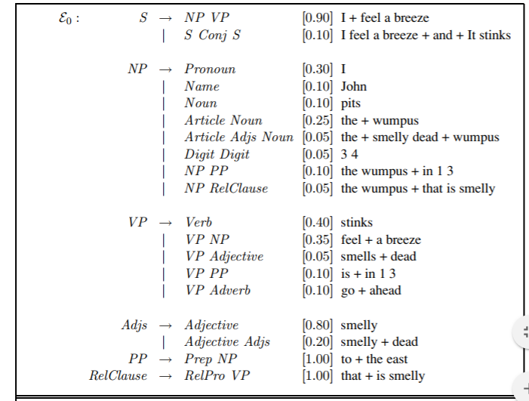

References

“Neural network poetry is so bad we think it's written by humans.” *New Scientist*, July 2017, [www.newscientist.com/article/2140014-neural-network-poetry-is-so-bad-we-think-its-written-by-humans/](http://www.newscientist.com/article/2140014-neural-network-poetry-is-so-bad-we-think-its-written-by-humans/).

Russell, Stuart J., and Peter Norvig. *Artificial intelligence: A modern approach*. Pearson Education, Inc., 2010.

“Iambic Pentameter” *Wikipedia,* January 2018,

<https://en.wikipedia.org/wiki/Iambic_pentameter>

“Conv Nets: A Modular Perspective” *Colah’s Blog,* July 2014,

<http://colah.github.io/posts/2014-07-Conv-Nets-Modular/>

“TakeLab”  
<http://takelab.fer.hr/sts/>

“Fundamentals of Deep Learning – Introduction to Recurrent Neural Networks” *Analytics Vidhya,* December 2017, <https://www.analyticsvidhya.com/blog/2017/12/introduction-to-recurrent-neural-networks/>